**MESD LMS Documentation – Send notifications to students and parents SMS/emails**

**Purpose**

To facilitate with sending SMS and emails to students and/or parents.

**Background**

This module handles requests directly from Educators within the Moodle system, allowing SMS and emails to be sent directly to leaners whenever needed.

**Usage**

**Adding the block**

1. Log in to Moodle as a Super admin.
2. Go to *‘Dashboard’,* turn on *‘Edit mode’* then *‘Add a block’.*

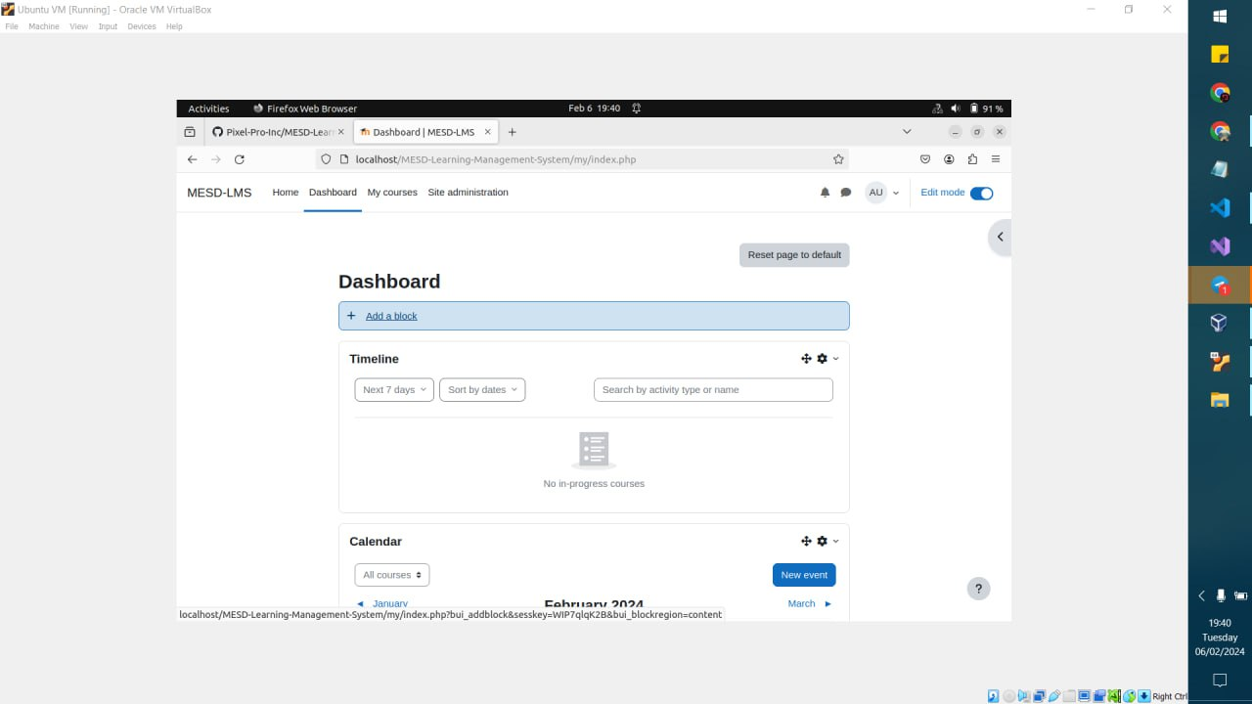

1. Look for the *‘Send Message’* option then click on itto add the Send Message block.

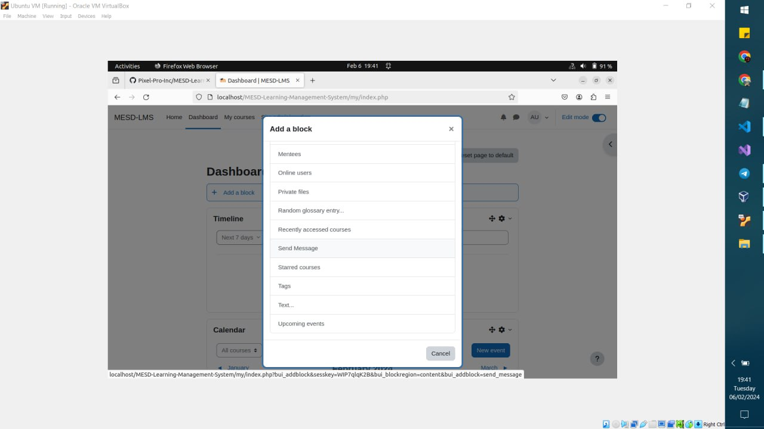

**Send an SMS/Email**

1. Login as an Educator.
2. Go to the dashboard and look for the ‘Send Message’ block.
3. Send SMS
   1. Select *‘Send SMS’*

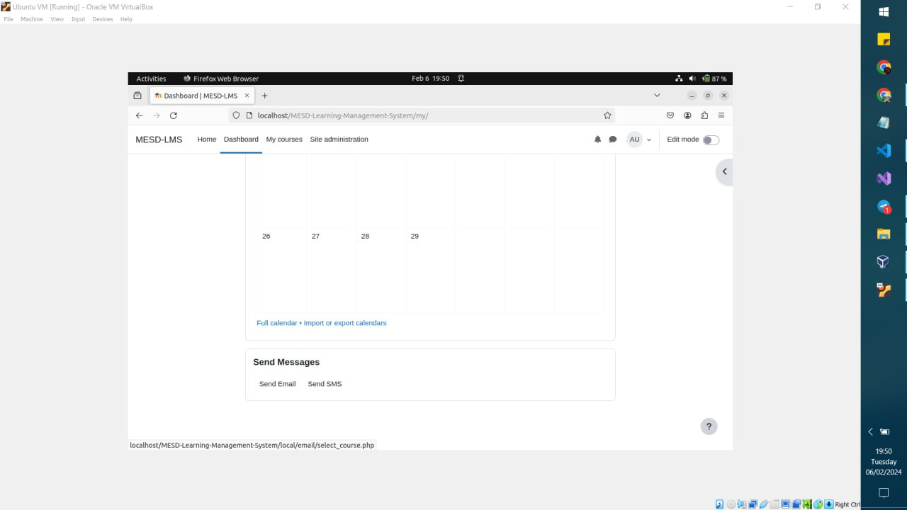

* 1. Select the course you want to send sms messages to then select *‘Save changes’.*

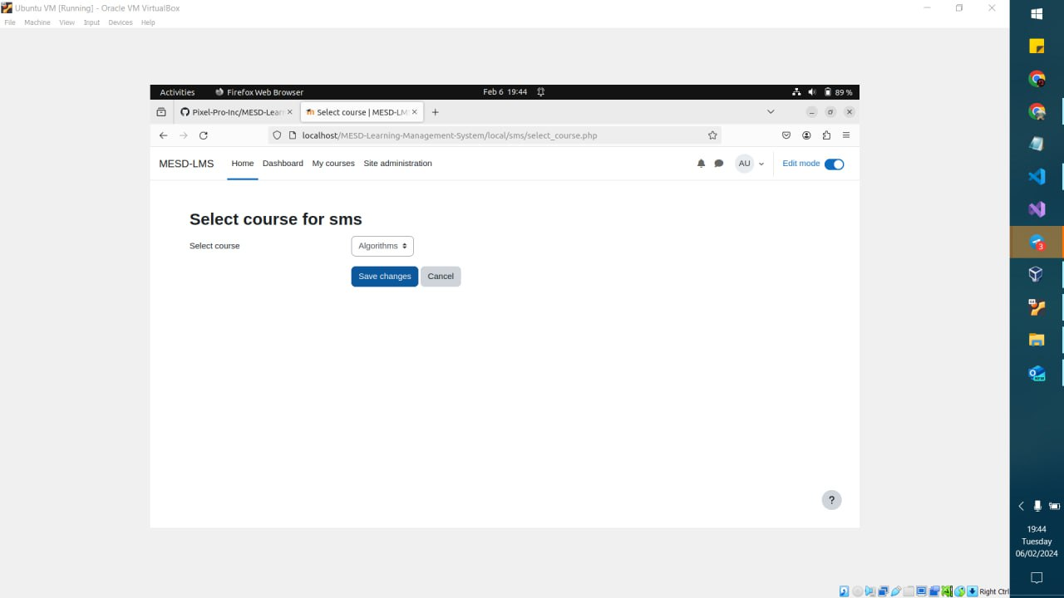

* 1. Once you get to the compose message page you should select users you want to send the SMS to by searching and selecting them under the drop down. Write a subject and enter the message.

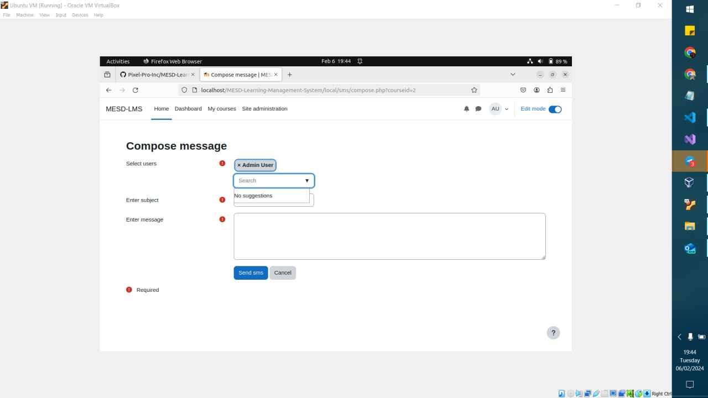

* 1. Once done select *‘Send sms’* to send the SMS.

1. Send email
   1. Select *‘Send Email’* from the block.



* 1. Select the course you want to send emails to then select *‘Save changes’* to proceed*.*
  2. Once you get to the compose emails page you should select users you want to send the email to by searching and selecting them under the drop down. Write a subject and enter the message. You can add an attachment if needed.
  3. Once done select *‘Send email’* to send the email.

**Developer Information**

Capabilities

local/email:composeemail: Allows users to compose emails

local/sms:composesms: Allows users to compose sms